TY B. Tech ECE AIML
Academic Session: 2025-26
Project Based Learning Activity
Course Name: DBMS
Student College and Stream Preference Analysis
and Recommendation System
Devish Darne | Jeel Bakrania
1262252298 | 1262252386
TY ECE AIML | TY ECE AIML
MIT-WPU | MIT-WPU
Pune, Maharashtra, India | Pune, Maharashtra, India

Abstract
Choosing an appropriate college and academic stream is an important decision for students because it can significantly influence their educational and professional careers. This paper presents a student preference analysis and recommendation system developed using Python, PostgreSQL, and Stream lit. The proposed system collects and analyzes student preferences for colleges and streams and transforms raw preference records into meaningful insights. PostgreSQL is used for structured storage and management of student data, Python-based analytical modules process preference information, and a recommendation module suggests suitable college–stream combinations using frequency and ranking logic. Streamlit provides an interactive web-based interface containing separate tabs for analysis, recommendations, and raw-data exploration. The database was enhanced with additional attributes, including twelfth score, gender, and age, and these fields were populated for 506 student records using randomized or patterned updates to simulate realistic data. The proposed system demonstrates how database management, data analytics, recommendation logic, and interactive visualization can be integrated into a practical educational decision-support application.
Keywords— Educational Analytics, Student Preferences, College Recommendation, Stream Recommendation, Python, PostgreSQL, Streamlit, Data Visualization, Decision Support System.

I. INTRODUCTION
Selecting a suitable college and academic stream is a complex decision involving several factors, including academic performance, student preferences, college popularity, stream selection, and personal characteristics. Traditional approaches to college selection often depend on manually comparing large amounts of information, making the process time-consuming and difficult for students.
The rapid development of data analytics and artificial intelligence provides an opportunity to develop intelligent systems capable of processing large student datasets and generating useful recommendations. Educational institutions can use such systems to understand student preferences, identify popular colleges and streams, and support data-driven decision-making.
This project presents an integrated system for analyzing student preferences and recommending college–stream combinations. The system combines PostgreSQL for database management, Python for data processing and recommendation logic, and Stream lit for developing an interactive web-based interface.
The main objectives of the proposed system are:
- To store and manage student preference data using PostgreSQL.
- To analyze student preferences using Python.
- To identify priority distributions and popular college choices.
- To recommend suitable college–stream combinations using ranking and frequency-based logic.
- To provide interactive visualizations through Streamlit.
- To enhance the dataset with additional student attributes.
- To provide an integrated platform for educational analytics and decision support.

II. SYSTEM ARCHITECTURE
The proposed system consists of four major components: the database connector, analyzer module, recommender module, and Streamlit user interface.
A. Database Connector
The database connector establishes communication between the Python application and PostgreSQL. It manages the database schema and tables and provides functions for retrieving and updating student information. The database contains 506 student records. Additional attributes include twelfth score, gender, and age.
B. Analyzer Module
The analyzer module retrieves student preference data from PostgreSQL and processes it using Python. It generates priority distributions, college preference frequencies, popular academic streams, student demographic distributions, and comparative preference patterns.
C. Recommender Module
The recommender module suggests suitable college–stream combinations using frequency and ranking information. A simplified recommendation score can be represented as R (c, s) = αF (c, s) + βP (c, s), where F (c, s) represents the frequency of a college–stream combination and P (c, s) represent its preference or ranking score.
D. Streamlit User Interface
Streamlit provides the interactive front end of the system. The interface contains Analysis, Recommendations, and Raw Data tabs, allowing users to explore analytical results, recommendations, and student records through a single application.

III. DATABASE DESIGN AND DATA PREPARATION
PostgreSQL is used as the backend relational database for storing student preference records. The dataset consists of 506 student records. The database was enhanced by adding twelfth score, gender, and age. The new fields were populated using randomized or patterned updates to simulate realistic data and demonstrate the functionality of the proposed educational analytics system.

TABLE I: STUDENT DATA ATTRIBUTES
Attribute | Description
Student ID | Unique identifier for each student
College Preference | Preferred college
Stream Preference | Preferred academic stream
Priority | Preference priority/rank
Twelfth Score | Class XII academic score
Gender | Student gender category
Age | Student age

IV. METHODOLOGY
The system follows the sequence of database creation, data population, data enhancement, data retrieval, data analysis, recommendation generation, visualization, and interactive dashboard deployment.
TABLE II: METHODOLOGY STEPS
Step | Methodology Stage | Description
1 | Database Creation | Create PostgreSQL database and required tables.
2 | Data Population | Store preference records for 506 students.
3 | Data Enhancement | Add twelfth score, gender, and age.
4 | Data Retrieval | Retrieve required records using Python.
5 | Data Analysis | Calculate priority distributions, top colleges, popular streams, and statistics.
6 | Recommendation Generation | Score and rank college–stream combinations using frequency and ranking logic.
7 | Visualization | Present analysis and recommendations using charts, graphs, and tables.
8 | Interactive Dashboard | Display results through Streamlit Analysis, Recommendations, and Raw Data tabs.

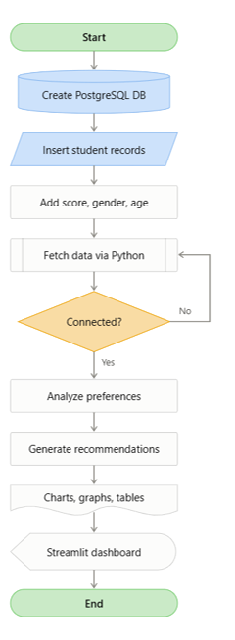
Fig. 1. Methodology flow chart of the proposed system.

V. SYSTEM IMPLEMENTATION
A. Python
Python serves as the primary programming language and performs database connectivity, data processing, analysis, recommendation generation, and visualization.
B. PostgreSQL
PostgreSQL provides persistent relational storage for student information and preference records. SQL queries are used to retrieve and manipulate the required data.

C. Streamlit
Streamlit is used to develop the interactive dashboard. It enables users to explore analytical results without directly interacting with SQL queries or Python code.

VI. RESULTS AND ANALYSIS
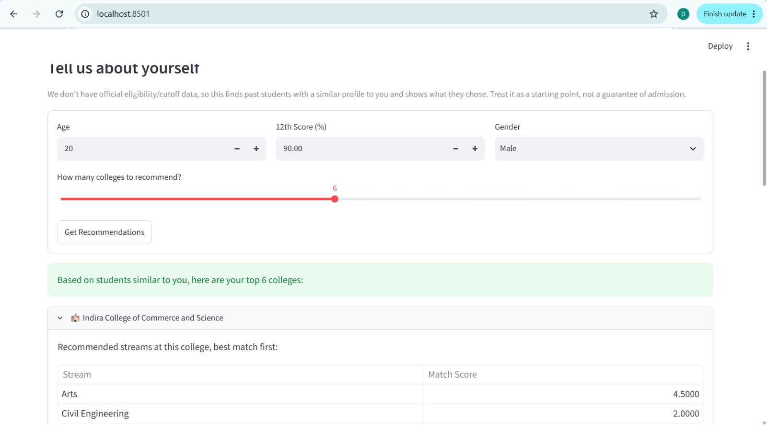
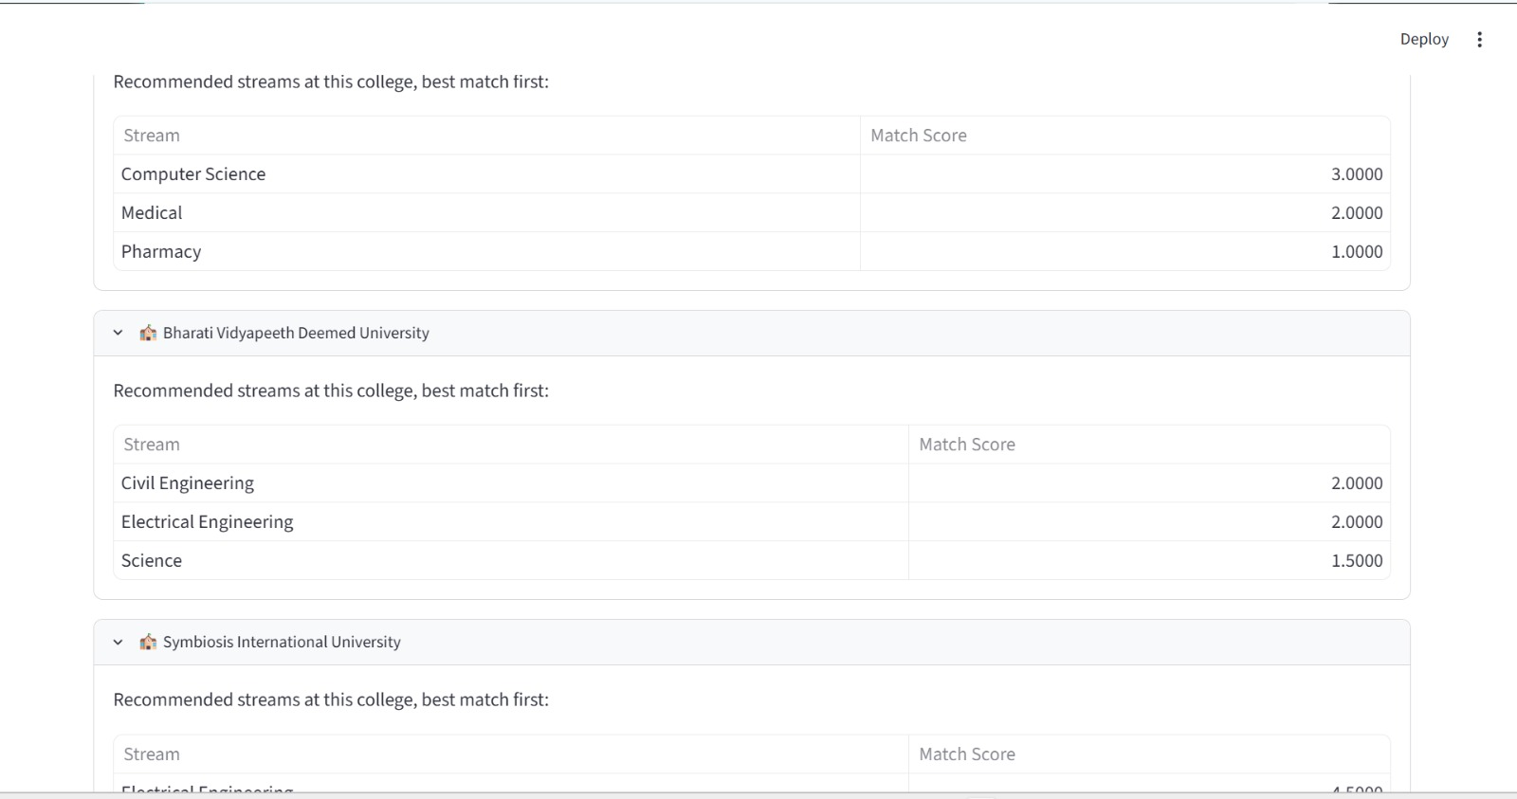
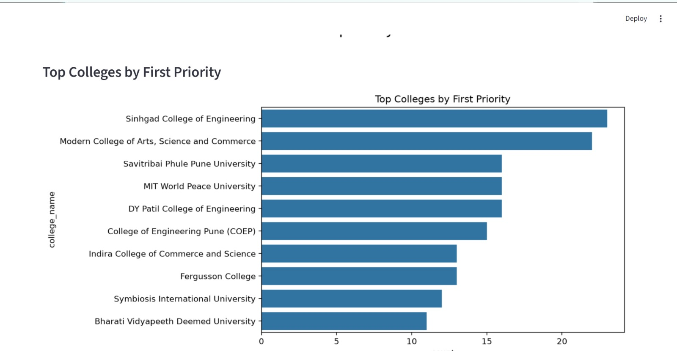
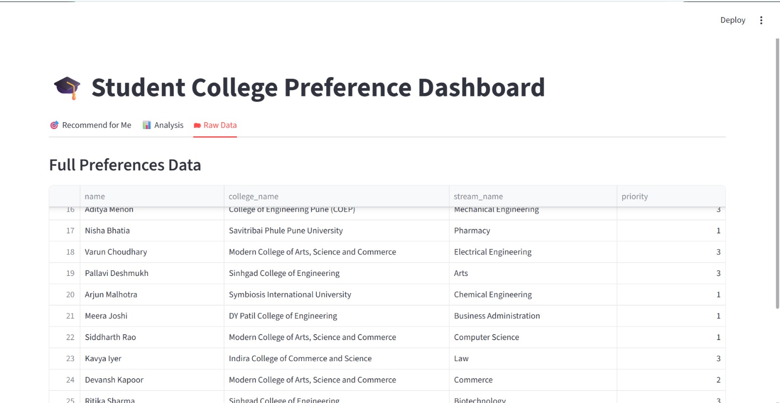

The developed system successfully transforms raw student preference records into meaningful analytical information and recommendations. Priority analysis identifies how students distribute their preferences across different levels. College preference analysis identifies frequently selected colleges, while stream analysis determines popular academic streams.
The recommender module combines these preference patterns to identify commonly preferred college–stream combinations. The results are presented through the Streamlit dashboard, allowing users to switch between analysis, recommendations, and raw data.

TABLE III: RESULTS AND ANALYSIS
Sr. No. | Analysis Parameter | Result / Observation | Interpretation
1 | Total Students | 506 | The dataset contains preference records for 506 students.
2 | Student Preference Data | College and stream preferences analyzed | Helps identify choices made by students.
3 | Priority Distribution | Preferences grouped by priority/ranking | Shows relative importance of different college choices.
4 | Top College Choices | Colleges ranked by selection frequency | Frequently selected colleges represent popular choices.
5 | Popular Streams | Stream preferences analyzed by frequency | Identifies the most preferred academic streams.
6 | College–Stream Combinations | College and stream preferences combined | Identifies frequently preferred combinations.
7 | Twelfth Score | twelfth score added for 506 students | Provides an additional academic parameter.
8 | Gender Distribution | gender field added and populated | Enables demographic analysis.
9 | Age Distribution | age field added and populated | Enables analysis across age groups.
10 | Recommendation Analysis | Frequency and ranking logic used | Generates suitable college–stream recommendations.
11 | Data Visualization | Charts and tables generated | Makes preference patterns easier to understand.
12 | Interactive Dashboard | Analysis, Recommendations, and Raw Data tabs | Provides an interactive exploration platform.
Fig. 2. Visual summary of results and analysis.

TABLE IV: SUMMARY OF SYSTEM RESULTS
Component | Input | Output | Purpose
PostgreSQL Database | Student records | Structured dataset | Store and manage data
Analyzer | Preference data | Statistics and distributions | Identify trends
Recommender | Frequency+  ranking data | College–stream recommendations | Support decision-making
Streamlit | Analysis+ recommendations | Interactive dashboard | Visual exploration
Raw-Data Module | Database records | Student data table | Explore original records

VII. ADVANTAGES
- Centralized student data management.
- Automated preference analysis.
- Interactive data visualization.
- Frequency and ranking-based recommendations.
- Modular system architecture.
- Easy scalability to larger datasets.
- Support for future machine-learning integration.
- Data-driven educational decision support.

VIII. LIMITATIONS
The additional demographic and academic fields were populated using randomized or patterned data and are therefore intended for demonstration purposes. The current recommendation system primarily relies on frequency and ranking logic rather than advanced machine-learning algorithms. It also does not comprehensively consider factors such as entrance examination scores, college fees, distance, placement statistics, available seats, or individual career goals. Therefore, the recommendations should be considered decision-support results rather than definitive admission advice.

IX. FUTURE SCOPE
The system can be enhanced by integrating machine-learning algorithms such as classification, clustering, collaborative filtering, and hybrid recommendation techniques. Future versions can incorporate entrance examination scores, admission cutoffs, fees, placement statistics, location preferences, student interests, and historical admission data. A personalized recommendation engine can also be developed to generate recommendations specifically for an individual student's academic profile and preferences.

X. CONCLUSION
This paper presented an educational analytics and recommendation system integrating Python, PostgreSQL, and Streamlit. PostgreSQL provides structured storage, Python performs data analysis and recommendation processing, and Streamlit provides an interactive dashboard.
The system analyzes 506 student records and converts raw preference information into meaningful insights such as priority distributions, popular colleges, popular streams, and recommended college–stream combinations.
The project demonstrates how database management, data analytics, recommendation logic, and interactive visualization can be integrated into a practical educational decision-support system. With real-world datasets and advanced machine-learning algorithms, the proposed system can be further developed into a personalized and scalable college-selection platform.

REFERENCES
[1] C. Romero and S. Ventura, "Educational data mining: A review of the state of the art," IEEE Trans. Syst., Man, Cybern. C, Appl. Rev., vol. 40, no. 6, pp. 601–618, Nov. 2010.
[2] PostgreSQL Global Development Group, "PostgreSQL Documentation."[Online].Available:https://www.postgresql.org/docs/. Accessed: Aug 28, 2026.
[3]Python-Software Foundation, “Python Documentation." [Online]. Available: https://docs.python.org/3/. Accessed: Aug. 28, 2026.
[4] Streamlit Inc., "Streamlit Documentation." [Online]. Available: https://docs.streamlit.io/. Accessed: Aug. 28, 2026.
[5] W. McKinney, Python for Data Analysis: Data Wrangling with Pandas, NumPy, and I Python, 3rd ed. Sebastopol, CA, USA: O'Reilly Media, 2022.
[6] C. C. Aggarwal, Recommender Systems: The Textbook. Cham, Switzerland: Springer, 2016.
[7] F. Ricci, L. Rokach, and B. Shapira, Eds., Recommender Systems Handbook, 2nd ed. New York, NY, USA: Springer, 2015.

